**Hands-on Lab 3:** Wireless Networking Lab *(working in pairs)*

**Objective:**

The purpose of this lab is to gain experience in configuring wireless networks. In your kit you are provided with a Wireless Router. The classroom laptops wireless adapters are already configured. Double check that the wireless adapter is enabled.

**Tools & supplies needed:**

* Lab tool kit
* 1 - Wireless Router / Access Point
* 1 - Cat5/5e Patch Cables

**Instructions:**

**Enable wireless access point:**

Begin by enabling the wireless adapter on the classroom laptop. If you need to re-boot your machine for any reason during this exercise, you will need to re-enable the wireless adapter.

**Configure wireless access point:**

Reset your wireless access point to original factory configuration (paper clip provided). You may need to do an internet search to find the original documentation for your specific wireless access point. The documentation should show how to reset your router, and how to login with the original admin account and password.

**D-Link support:**

<http://www.support.dlink.com/emulators/dir855/Wizard_Wireless.html>

* Change the SSID and encryption security on your wireless access point to create a more secure network. Configure computers to communicate with the increased security. Verify you are able to connect with both computers. ***Take a screenshot of the access point management utility showing the new settings.***

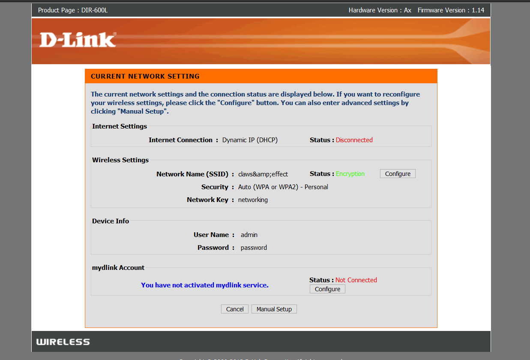

* Set the wireless access point to limit access by MAC address. Include the MAC addresses of both computers in the access list. ***Take a screenshot of the access point management utility showing the new settings.***
* 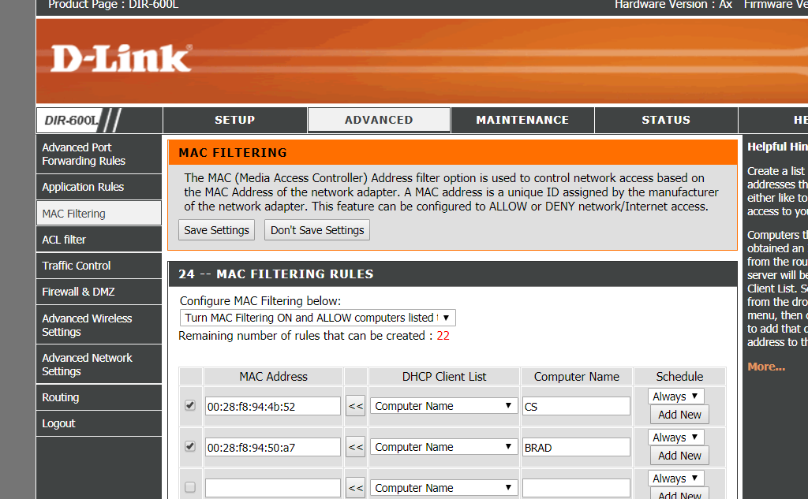
* Connect the wireless access point to the classroom network and configure it to provide internet access for both computers.
* 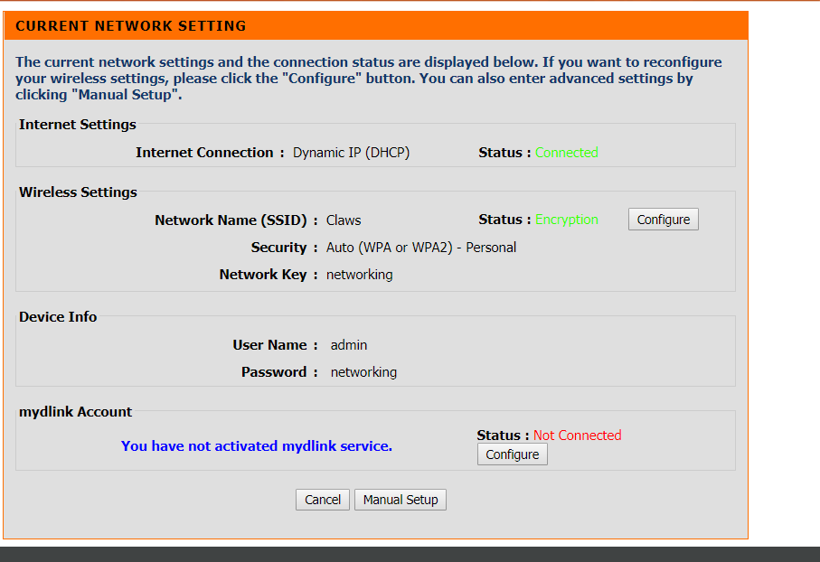
* Configure your access point to limit the number of DHCP addresses distributed to no more than 10 addresses (**hint:** use D-Link access point management utility)**. *Take a screenshot of the access point management utility showing these new settings.***
* 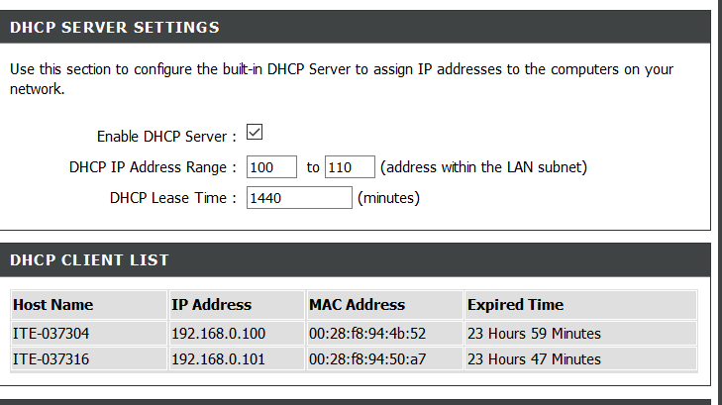
* Configure your wireless access point to allow both computers to communicate. Use Windows Explorer (File Explorer) / Network & Sharing to discover the network devices. ***Take a screenshot of all three devices in Network.***

